Controlling

Controlling is the basic managerial function. It is the process of ensuring the actual activities confined to planned activity. It is an essential function for all levels of management. It ensures the right things are done in the right manner at right time. Each and every organization set the goals. All activities are directed towards the goals. Controlling is defined as a measurement of Actual performance and expected performance and taking corrective action. Its purpose is to make sure that actual performance is consistent with plans. In fact control helps managers to monitor the effectiveness of their planning, their organizing and their directing activities.

**Process of controlling**

1. **Establishing or setting standards**: The first step of controlling is to set standard against which results can be measured. For setting standard, targeted results must be identified and it should be quantitative as far as possible. Quantitative term can make controlling effective. Standards can be expressed in qualitative as well as qualitative terms. The quantitative are physical standard, cost and revenue standards, capital standards etc. the qualitative standards are related to employees morale, motivation, relations between superior and subordinates and public etc. quantitative standard should be flexible.
2. **Measuring actual performance**: In this step, actual performance of employees, group or units is measure. A manager should examine actual performance on the basis of given standard which is definite set of work assigned to definite employees different techniques can be used to measure the actual performance. In convenience of manager, he develops better information system to measure the actual performance. Actual performance measurement system should be a regular and constant basis so that it can provide reliable and regular feedback to the management.
3. **Comparing actual performance with standard:** After measuring actual performance, those results should be compared with standard set in the first step to know if the exp results are achieved or not . For that, good sys of comparison between performance and standard should be maintained. These comparison should reveal it the actual performance is equal, lower or higher than that of predetermined standards. If lower standards are achieved the manager should find out the deviation and take corrective action.
4. **Taking corrective actions**: After comparing actual performance with the standard, if any deviation is detected, and then corrective actions should be taken and initiated. If performance does not meet the standard, it is duty of manager to take corrective action and further help the organization to overcome any difficulty. The corrective action may be related to:-
   1. Revision of standard if they seem to be unattainable
   2. Revision of strategies, policies and procedures
   3. Additional employees training
   4. Greater motivation
   5. Change in the existing technique of direction
   6. Product design improvement

**Techniques of Control**

**Breakeven Analysis:**

The technique used by managers to study the relationship between sales volume, costs and profit is known as Breakeven Analysis. This technique helps the managers in estimating profits at different levels of activities. The following figure shows breakeven chart of a firm.

The point at which the total revenue and total cost curves intersect is breakeven point. The figure shows that the firm will have the breakeven point at 60,000 units of output. At this point, there is neither profit nor loss. The firm starts earning profit beyond this point.

Breakeven Point= Fixed Cost/ (Selling Price per unit- Variable cost per unit).

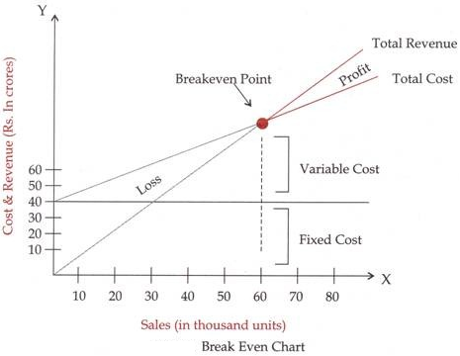

Through breakeven analysis, a firm can keep a check on its variable cost and can also determine the level of activity at which it can earn its profit target.

**Budgetary Control:**

Under this technique, different budgets are prepared for different operations in an organisation in advance. These budgets act as standards for comparing them with actual performance and taking necessary actions for attaining organisational goals.

A budget can be defined as a quantitative statement of expected result, prepared for a future period of time. The budget should be flexible so that necessary changes, if need be, can be easily made later according to the requirements of the prevailing environment.

**Network Analysis (CPM/PERT)**

Network diagrams are schematic displays of project schedule activities and the interdependencies between these activities. It is a graphical flow plan of the activities that must be accomplished for completing the project. Network based scheduling or Network Analysis comes handy in solving complex project scheduling problems.

Network analysis is used to determine / assess:

* How long will the entire project take to be completed? What are the risks involved?
* Which are the critical activities or tasks in the project which could delay the entire project if they were not completed on time?
* Is the project on schedule, behind schedule or ahead of schedule?
* If the project has to be finished earlier than planned, what is the best way to do this at the least cost?

**CPM (Critical Path Method)** and **PERT (Program Evaluation Review Technique)** are project management techniques, which have been created out of the need of Western industrial and military establishments to plan, schedule and control complex projects.

The key concept used by CPM/PERT is that a small set of activities, which make up the longest path through the activity network control the entire project. If these **"critical"** activities could be identified and assigned to responsible persons, management resources could be optimally used by concentrating on the few activities which determine the fate of the entire project. Non-critical activities can be re-planned, rescheduled and resources for them can be reallocated flexibly, without affecting the whole project.